INDEX

Sr No | Topic Name | Page No
1.0 | Introduction | 2
2.0 | What is Datadog? What are the key Use cases? | 3
2.1 | Pros and cons of implemented tool | 3
3.0 | Why do we need Datadog? | 3-4
4.0 | Overview of Datadog tool | 5-21
5.0 | Costing plan | 22-23

- Introduction
______________________________________________________________________
Currently, the performance and reliability of web services applications, and monitoring tools are crucial parts of IT infrastructure
Monitoring is essential to ensure the application’s reliable operation. As software development, monitoring and alerting become important practices for DevOps teams.
There are several monitoring tools available in the market. Among these, Datadog has emerged as a popular choice, offering comprehensive solutions for monitoring servers, databases, tools, and services.
we have done a detailed overview of Datadog tools and their features on the demo account. we'll discuss in this blog how we configured the use cases and how it will help us with the current setup.
This blog post dives into what Datadog is, and its key features, uses comparison with running monitoring setup and pricing, and concludes with its overall impact on the infrastructure.

2.0 What is Datadog?
Datadog is a cloud-based monitoring platform that provides deep insights into the IT environment. Organizations can use Datadog to monitor their infrastructure, applications, logs, databases, and other data sources.
The following are some key features.
Infrastructure monitoring: - It allows us to monitor the cloud infrastructure, windows, Linux servers, serverless, system processes, and network performance.
Application performance monitoring (APM): - In APM, we can measure the application’s performance in real-time. It provides end-to-end tracing from hosts, containers, and databases.
Log Management: Easy to analyze the logs for rapid troubleshooting. It helps us to gain insight efficiently.
DB Monitoring: - Monitor every query performance, load traffic, and logs for DB.
Container monitoring: Container monitoring provides real-time visibility into the health and performance of a containerized environment.
Synthetic monitoring: - Monitor critical application features using an Al-driven synthetic test.

3.0 Pros and cons of implemented monitoring tools
Zabbix:
Pros:
- Free and Open source
- Easy to use
- Server-level and application-level monitoring
- Easily set an alert
Cons:
- It doesn’t support docker and Kubernetes platform
- Zabbix needs to integrate Amazon RDS
Grafana
Pros:
- Free and open source
- Wide range data visualization
- Multiple plugins for data sources
- Easy to install
Cons:
- Limited visualization dashboard
- It doesn’t support log analysis

DYNATRACE
Pros:
- Hybrid application
- Support APM(Application performance monitoring )
- Real user monitoring
- Support distributed tracing for microservices
Cons:
- Costly
- Doesn’t support log analysis and DB monitoring
- Slow running application.

4.0 Why do we need Datadog?
Datadog monitors the performance and health of applications and infrastructure. It helps us in various scenarios, such as
Performance optimization: help applications identify and rectify performance bottlenecks
Troubleshooting: Providing a detailed overview for quick and effective problem-solving.
Security Monitoring: Offering insights into security threats and vulnerabilities.
AWS integration: It offers AWS services for monitoring their data in real-time.
Capacity Planning: Assisting in effective planning of IT resource allocation

4.1 Components of Datadog
Agent
Datadog-agent is a key component that runs on the host. It collects all the metrics and sends them to the Datadog-UI, where we can analyze monitoring and performance data.
For a standalone machine, we should install the Datadog-agent package on the machine. This standalone package is available for Amazon EC2, Centos, Debian, Red Hat, and Ubuntu. This agent also runs in a containerized environment and Amazon ECS

We have installed an agent on an Amazon Ec2 machine and metrics are visible. There are some steps to install the agent on different environments.
API
Datadog offers a RESTful API that allows you to interact with the platform programmatically. We can use the API to query the data, custom dashboards, and other task.
INTEGRATION
Datadog provides integration with a wide range of technologies, such as cloud platforms, databases, monitoring tools, and more. These allow us to integrate with various data sources and display them on Datadog.
Datadog backend
The DataDog backend is responsible for processing and storing the collected data. It consists of various services that handle data ingestion, storage, analysis, and visualization.
User Interface
The DataDog user interface provides a web-based interface for visualizing and analyzing collected data. It offers customizable dashboards, graphs, and alerts to monitor the health and performance of your systems.

4.2 Agent 7.0 installations
For a standalone machine: - In a standalone machine, we should install the agent with one line command. A standalone package is available for Amazon Linux, CentOS, Debian, Fedora, Red Hat, SUSE, and Ubuntu. To install the setup, please follow the link https://app.datadoghq.eu/account/settings/agent/latest?platform=aws
Docker: Install and configure the agent on the containerized environment. Run the docker command on the working host. To install the setup, please follow the link Agent 7 | Datadog (datadoghq. eu)
Amazon ECS: - The Datadog-agent in ECS will be deployed as a container on the EC2 instance of the ECS cluster. This is done by adding the new service to the ECS cluster.
The newly created service will monitor the container application easily.
Manage the Task definition:
- Add the Task definition with two parameters.
- Set <Your Datadog API KEY> of Datadog account.
- Set the DD_SITE environment variable to datadoghq. EU
- Add the Datadog-agent ECR image.

- Create a new service for the Datadog-agent and run it as a daemon Service on the ECS cluster.

4.3 Overview of Datadog tool

4.4 Infrastructure Monitoring
Infrastructure monitoring is used to collect and perform data from servers, virtual machines, containers, databases, and other backend components.
It includes core Datadog features that visualize, monitor, and measure the performance of the hosts, containers, and processes.
First, we have to install the agent on the Ec2 servers. After installation, the agent collects infrastructure metrics from hosts and sends the data to the monitoring dashboards for visualization.

we have installed the Datdog-agent on AWS Irland EC2 servers. For those Ec2 servers, we can be able to see the matrices easily.
The following are the infrastructure hosts that we added to the trial account.
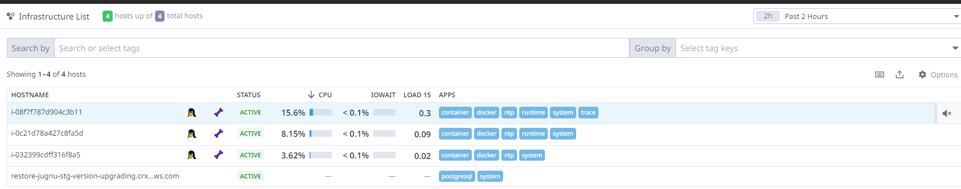

Referring to the above image, there are three Amazon Ec2 servers and one database host added to the Datadog account. There is a full visualization of the data after adding it to the Datadog account. It includes all the system information related to the Platform, CPU, memory, Network & Filesystem.

The following is the running host information on the data dog.
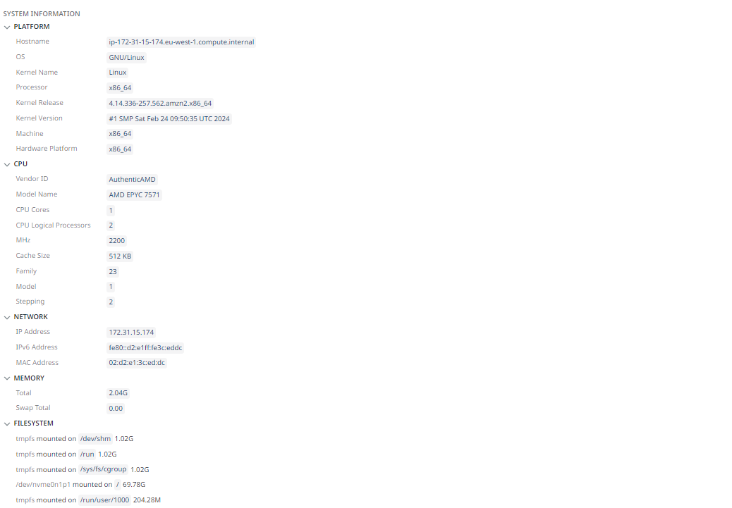

In infrastructure monitoring, it also monitors the container applications and running processes on hosts.
This includes the following topics :
Container View:
In Container Monitoring, the Datadog provides real-time visibility into all containers across our environment. It includes all components coupled with Docker, Kubernetes, and ECS, the container page provides a detailed overview of the Container’s health, resource consumption, logs, and deployments in real time.

We have captured the container monitoring on added hosts.
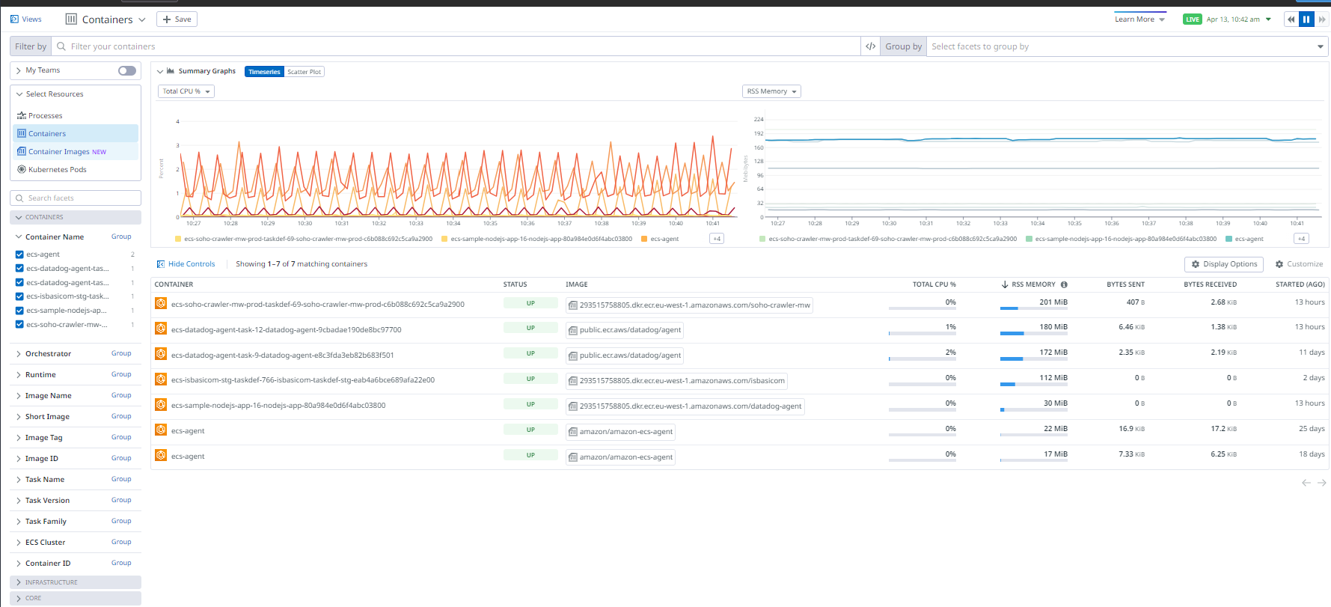

From the above image, we can quickly see which images are running on the docker container and their specific running versions. Using tags, we can filter and group using any metadata attached to containers.
Inside the container
From the container map’s inspection panel, the Datadog provides the live container view to drill further into the container’s health and resource usage. In the live container view, we can sort the containers by resource consumption and inspect the process-level system metrics.
Container Image View
In container image, It also detects and remediates security and performance issues that can affect multiple containers. It also helps to view the container image details alongside the rest of the container data to troubleshoot image issues affecting infrastructure health.

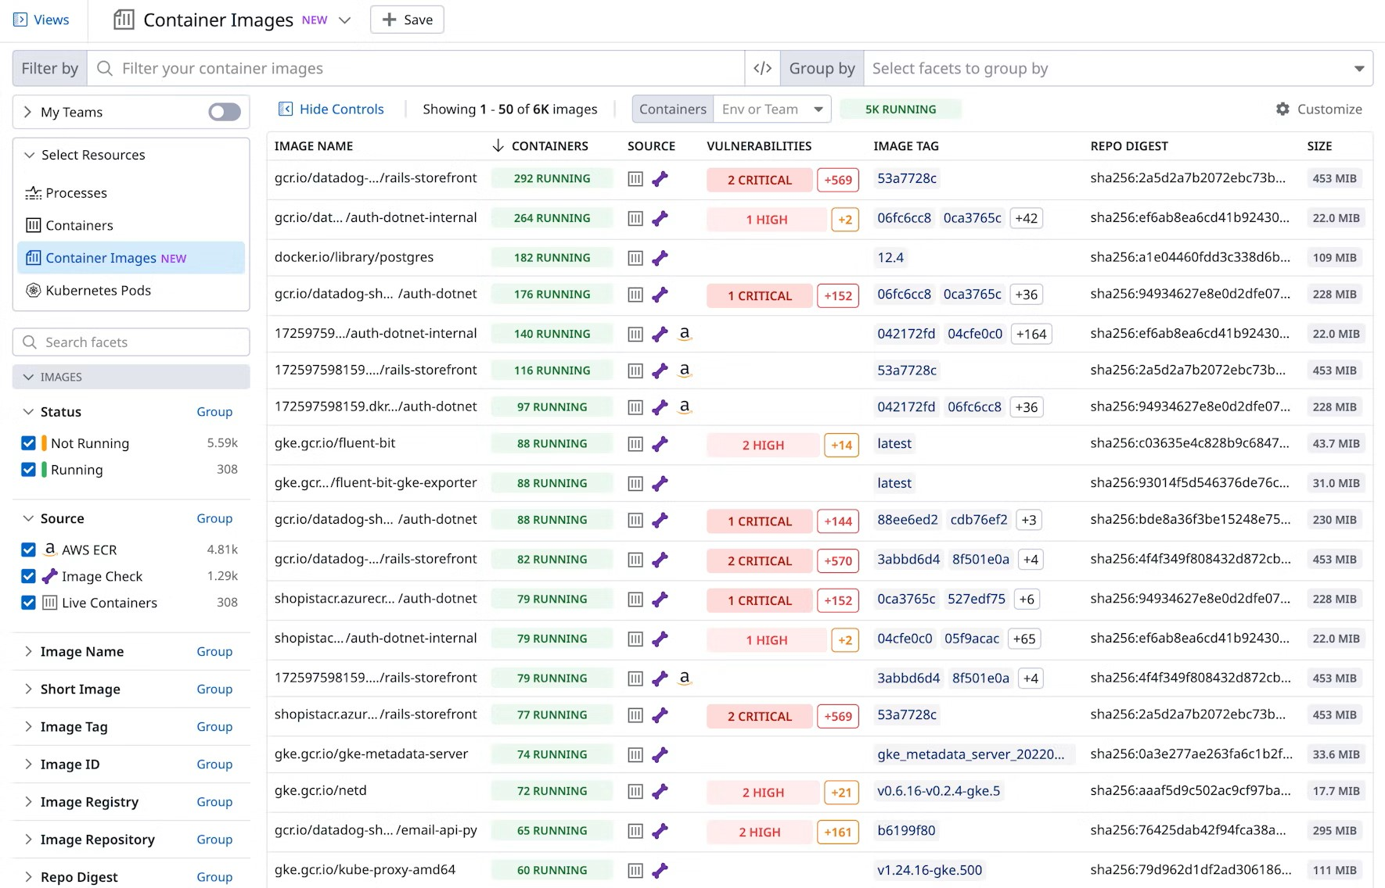

Configure the agent :
To enable the Docker image scan features, the following are the steps
For EC2 Agent :
Add the following to your datadog.yaml
Sbom:
enabled: true
container_image:
enabled: true
container_image enabled: true

For ECS EC2:
To enable image scanning on ECS EC2 instances, add the following environment variables to your Datadog-agent container definition.

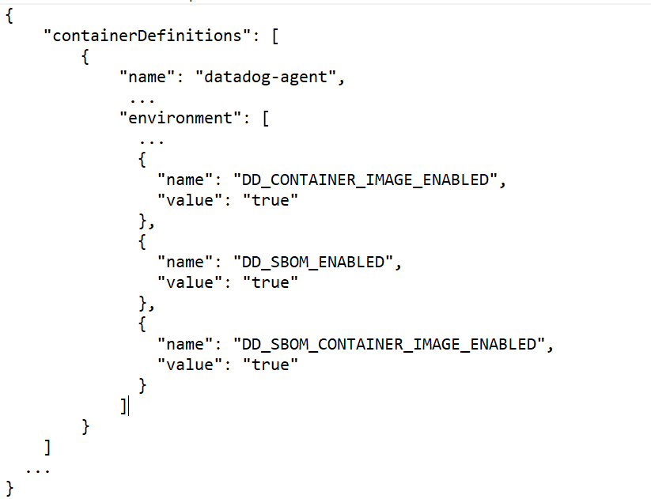
Process View:
Datadog’s live process gives real-time visibility into the process running into the added hosts.
Use the running process for the below checks:
- View all running processes in one place.
- Query for the process running on the specific host, in a specific zone
- Resource consumption for every running process
- Add the dashboard for visualization

We have enabled the Process view on added hosts and captured the real-time running processes on it. The below screenshot is showing the running processes and their
resource consumption for added hosts.
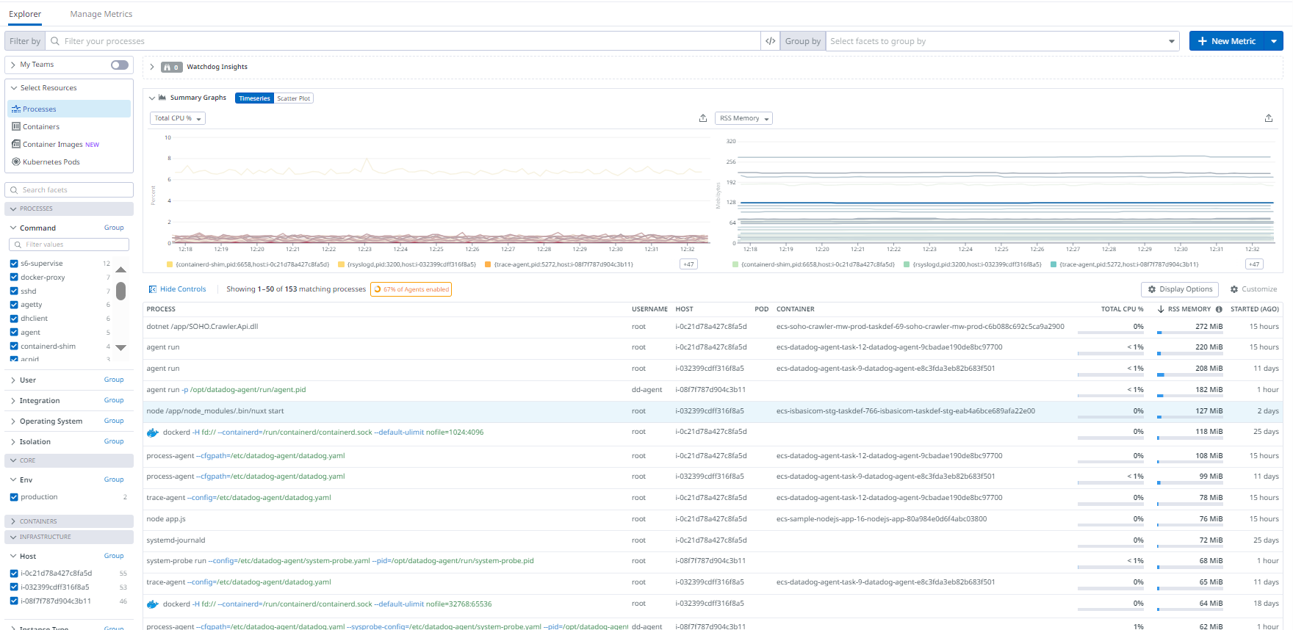

Installation
EC2 :
To enable the live running process, add the following configuration on the data dog-.yaml file.
Process_config:
Process_collection:
enabled: true

Note: After adding the configuration, we should restart the Datadog-agent host

Docker:
In the docker agent environment, needs to add following additional parameters.
-v /etc/passwd:/etc/passwd:ro
-e DD_PROCESS_CONFIG_PROCESS_COLLECTION_ENABLED=true
I/O stats
I/O and open file states can be collected on Datadog system probe. To enable the process of system probe , use the following configuration

- Copy the system-probe example configuration

-u dd-agent install -m 0640 /etc/datadog-agent/system-probe.yaml.example /etc/datadog-agent/system-probe.yaml

- Edit /etc/datadog-agent/system-probe.yaml to enable the process module

System_probe_config:
Process_config:
enabled: true
- Restart the agent
systemctl restart datadog-agent

4.5 Network Performance Monitoring
Network performance monitoring gives you visibility into the network traffic between services, containers, availability zones, and other tags in Datadog. We can see the connection data at the IP, Port, and PID levels between the client and server endpoints which can be analysed and visualized through a customizable network page and network map.
The following key functions can be identified through NPM
- Unexpected or latency service
- Troubleshooting client and server-side DNS server issues
- Identify the outage of the cloud provider and third-party tool
- Troubleshooting faulty service discovery with DNS server metrics.
We have enabled the NPM (Network Performance Metrics)feature on the added host. The Client-side and server-side requests are visible on Datadog UI.NPM supports Linux, windows, and also containerized environments.
Setup:
EC2 Agent:
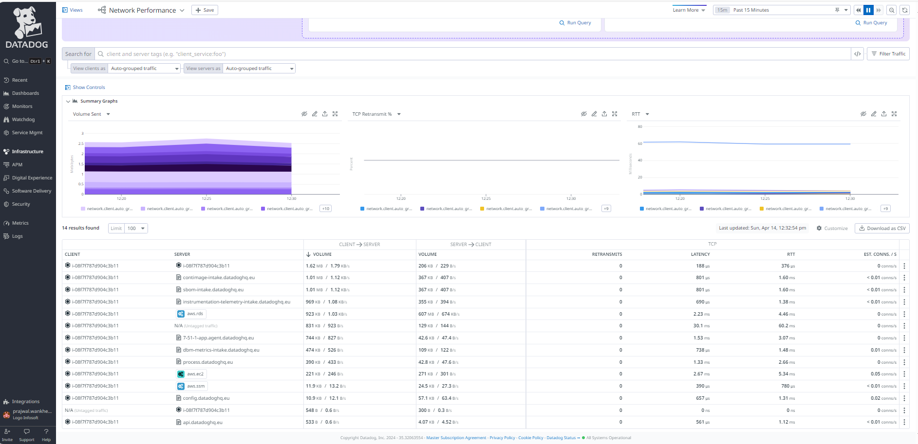

To enable the network performance monitoring with Datadog-agent , use the following configurations.
- Copy the System-probe example configuration

-u dd-agent install -m 0640 /etc/datadog-agent/system-probe.yaml.example /etc/datadog-agent/system-probe.yaml

- Edit /etc/datadog-agent/system-probe.yaml to enable flag to true:

netwok_config: # use system_probe_config for Agent's older than 7.24.1
## @param enabled - boolean - optional - default: false
## Set to true to enable Network Performance Monitoring.

enabled: true

- Start the datadog-agent-sysprobe

systemctl start datadog-agent-sysprobe

- Restart the datadog-agent

Systemctl restart datadog-agent

Docker:
Add the below - configurations on the docker’s host command line
- -e DD_SYSTEM_PROBE_NETWORK_ENABLED=true \
ECS :
Add the variable on the task definition of the ECS host

- {
- "name": "DD_SYSTEM_PROBE_NETWORK_ENABLED",
- "value": "true"
- }

DNS Monitoring
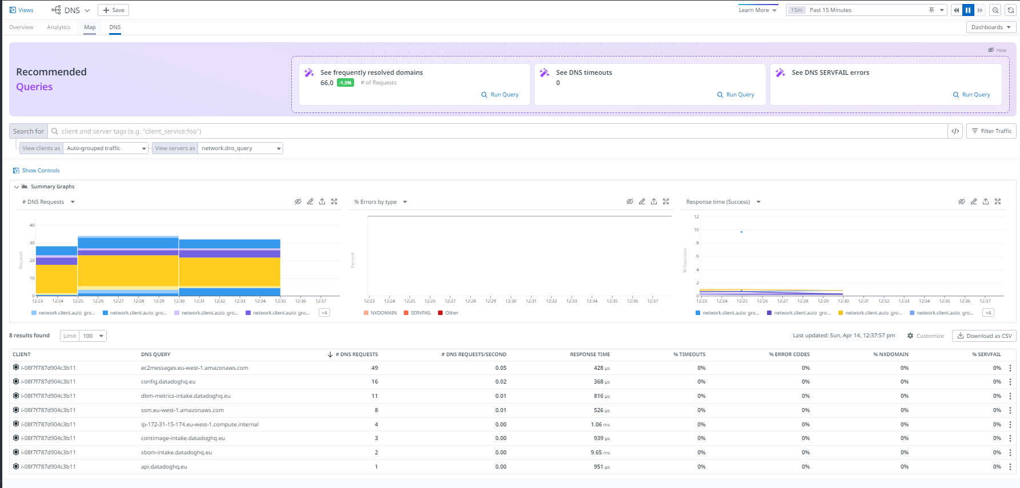

DNS monitoring provides an overview of DNS server performance to help you to identify the server-client issues. By seeing these metrics, we can identify the following key components
- DNS endpoints making the most requests or making requests at the highest rate.
- If the DNS’s response time suddenly increases
- The DNS server with a high error rate & which type of error being emitted

4.6 APM (Application performance monitoring)
Application performance monitoring is important in supporting DevOps practices by providing comprehensive insights into application performance. The APM UI provides many tools to troubleshoot application performance and enables us to find and resolve issues in distributed systems.
We have used the APM tool for distributed tracing. The following are the definitions:
Distributed tracing: A trace is the time spent processing the application request and the status of the request. All the incoming requests for applications and the status of every request are displayed in Datadog. Each trace consists of one or more spans.
For a lifetime of requests, each request is divided by trace-id on HTTP headers and distributed the calls across the service.
Application Instrumentation: Instrumentation is the process of adding the code on the application side for capturing such traces, metrics, and logs. Datadog provides the instrumentation library for each programming language and framework that we use.
Captured the GET/POST tracing requests, for Nodejs application on APM UI. The following is the captured request for the Nodejs application.
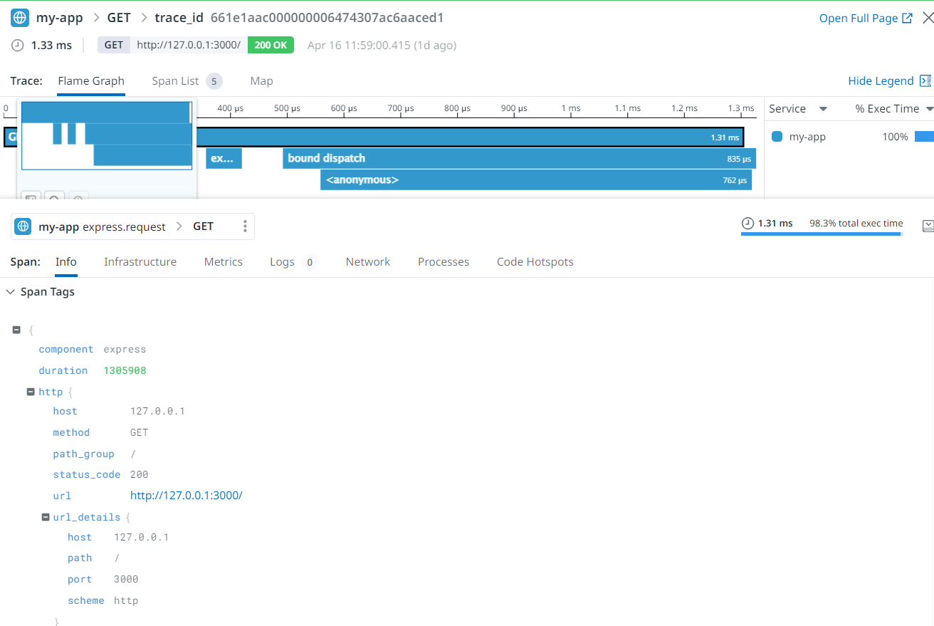

From the above image, in the trace view page, each request contains some information related to the tag, running metrics, and logs collection. It includes all incoming information related to the third person’s request like the host, the host’s request, status code, URL info, and which language is referred by the application. The metrics view gives an overview of the no. of running requests, total error requests, and no. of latency requests on running Nodejs applications.

The metrics view for each request
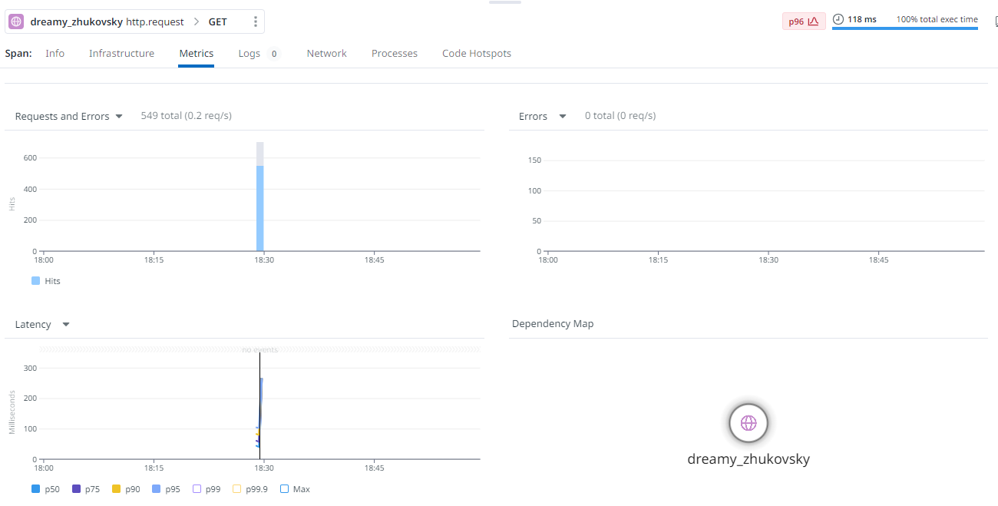

Application instrumentation:
Setup:
- Install and configure the Datadog-agent.
- Instrument the application.
Instrumenting the application means the tracer agent sends the observability data to the agent then, the agent displays it on the Datadog-UI side.
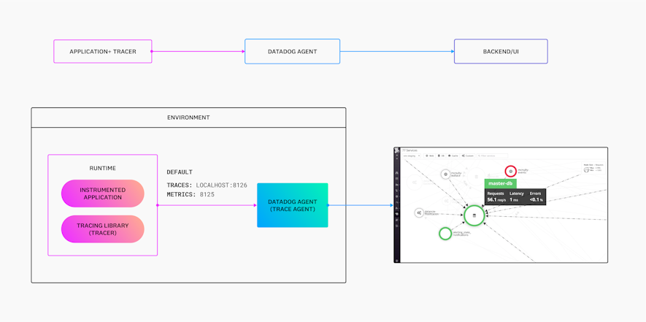
To automatically instrument the application, we can use the following key steps :
- Single-step instrumentation: Run a one-line command to install the Datadog agent, enable APM, and instrument all of our services on the Linux host, VM, or container.
- Adding tracing libraries to applications
We have set the instrumentation tracing on the Nodejs application. The following are the steps for adding to the application.

- Install the dd-agent on the host
The Datadog agent is used to send traces from our tracing libraries.

- Install the Javascript client.
This is the tracing client required for the environment and language.
npm install --save dd-trace.

- Configuring Nodejs tracing library:
To instrument the application, add the below snippet to the application code.
// This line must come before importing any instrumented module.
const tracer = require('dd-trace').init()

and we can see the live requests for the running application. We have sent the Curl GET/POST requests, and the traces are visible on the Datadog-UI side.
We have captured these requests for the Nodejs application
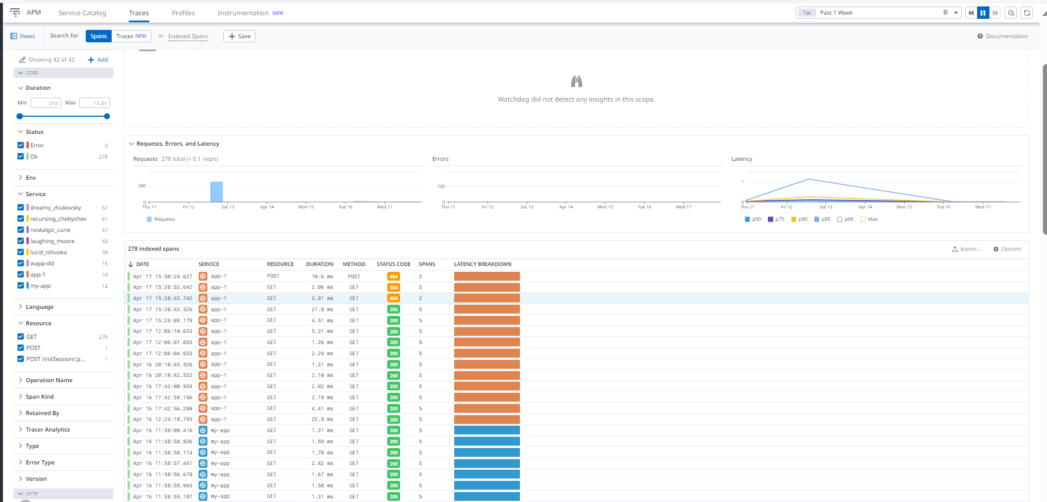

On the left side of the image, the detailed information about the request like service name, status code, language name, resource per request, and other information, etc.
4.7 Database Monitoring
Datadog Database monitoring provides deep visibility into the database across all of the hosts. It includes historical query performance metrics, explain plan, and host-level metrics in one place to understand the health and performance of our database and troubleshoot issues as arise.
Datadog supports self-hosted and cloud versions of Postgres, MySQL, Oracle, and SQL servers.
We have installed the configuration on one Postgresql RDS instance of AWS Ireland. It provides deep visibility into the Postgres database by exposing query metrics, query samples, explanations of plans, database states, failovers, and events.
The Agent collects telemetry directly from the database by logging in as read-only user
The following are the steps, we performed:
Configure Postgres parameter:
Configure the following parameters in the DB parameter group and then restart the server for the settings to take effect.
Parameters value
shared_preload_libraries pg_stat_statements
track_activity_query_size 4096
pg_stat_statements.track ALL
pg_stat_statements.max 10000
pg_stat_statements.track_utility off
track_io_timing on

Grant the Agent process
The Datadog Agent requires read-only access to the database server to collect statistics and queries. The following SQL commands should be executed on the primary database server (the writer) in the cluster if Postgres is replicated. Connect to the chosen database as a superuser (or another user with sufficient permissions).
For example, if your chosen database is postgres, connect as the postgres user using psql by running:
psql -h mydb.example.com -d postgres -U postgres
Create the datadog User
CREATE USER datadog WITH password '<PASSWORD>';ser:
Give the datadog user permission to relevant tables:
ALTER ROLE datadog INHERIT;
Create the following schema in every database:
CREATE SCHEMA datadog;
GRANT USAGE ON SCHEMA datadog TO datadog;
GRANT USAGE ON SCHEMA public TO datadog;
GRANT pg_monitor TO datadog;
CREATE EXTENSION IF NOT EXISTS pg_stat_statements schema public;
Create the function in every database to enable the Agent to collect and explain plans.
CREATE OR REPLACE FUNCTION datadog.explain_statement(
l_query TEXT,
OUT explain JSON
)
RETURNS SETOF JSON AS
$$
DECLARE
curs REFCURSOR;
plan JSON;
BEGIN
OPEN curs FOR EXECUTE pg_catalog.concat('EXPLAIN (FORMAT JSON) ', l_query);
FETCH curs INTO plan;
CLOSE curs;
RETURN QUERY SELECT plan;
END;
$$
LANGUAGE 'plpgsql'
RETURNS NULL ON NULL INPUT
SECURITY DEFINER;
Install the Agent
To monitor RDS hosts, install the Datadog Agent in your infrastructure and configure it to connect to each instance endpoint remotely.
Host:
Edit the postgres.d/conf.yaml file to point to your host/port and set the masters to monitor.
init_config:
instances:
- dbm: true
host: '<AWS_INSTANCE_ENDPOINT>'
port: 5432
username: datadog
password: '<PASSWORD>'
Monitoring multiple databases on a database host
Use the database_autodiscovery option to permit the Agent to discover all databases on your host to monitor
database_autodiscovery:
enabled: true
# Optionally, set the include field to specify
# a set of databases you are interested in discovering
include:
- mydb.*
- example.*
Query Metrics
The Query Metrics view shows historical query performance for normalized queries. Visualize the performance of every database infrastructure or custom tag such as data center availability zones, and get alerted for anomalies.
The Query Metrics list shows Requests, Average latency, Total time, and Percent time metrics, plus others that depend on your database product.
We have captured the view of Postgres RDS jugnu after adding the configuration of
Datadog on it . The following is the query metrics view :

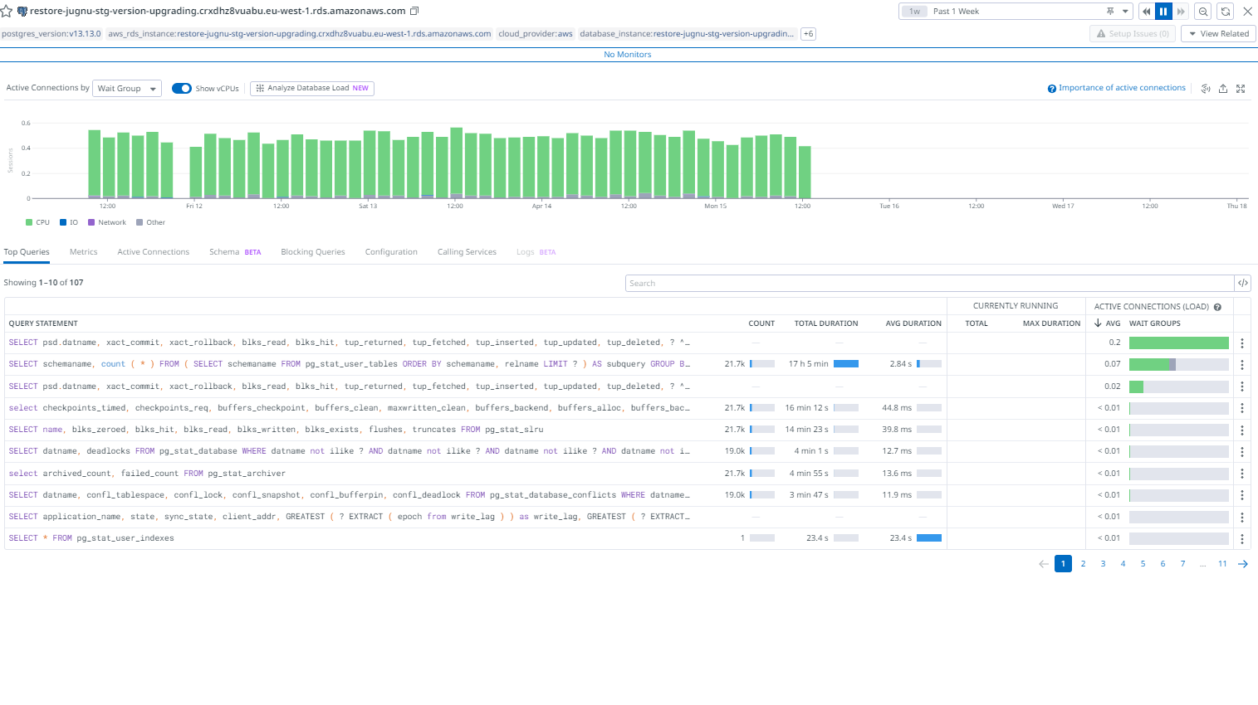
When we click a query in the Query Metrics list, the Query Details page for that query opens. The top of the page shows the full text of the query and a list of all tags associated with the query.
The list of tags is the union of all tags from each host that the query runs on. Browse the list to see information such as what server the query is running on:
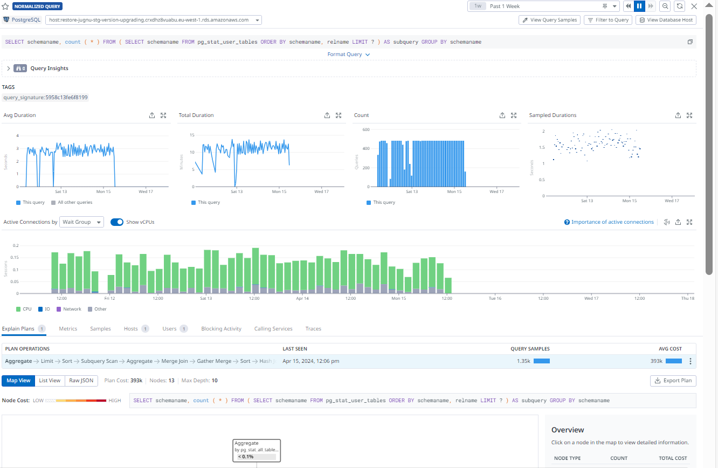

Query Sample: helps you understand which queries were running at a given time. Compare each execution to the average performance of the query and related queries.
The Samples page shows a snapshot in time of running and recently finished queries.
Graphs show the query’s performance metrics—number of executions, duration, and rows per query—over the specified time frame if it is a top query, with a line indicating the performance for the sample snapshot you’re looking at.
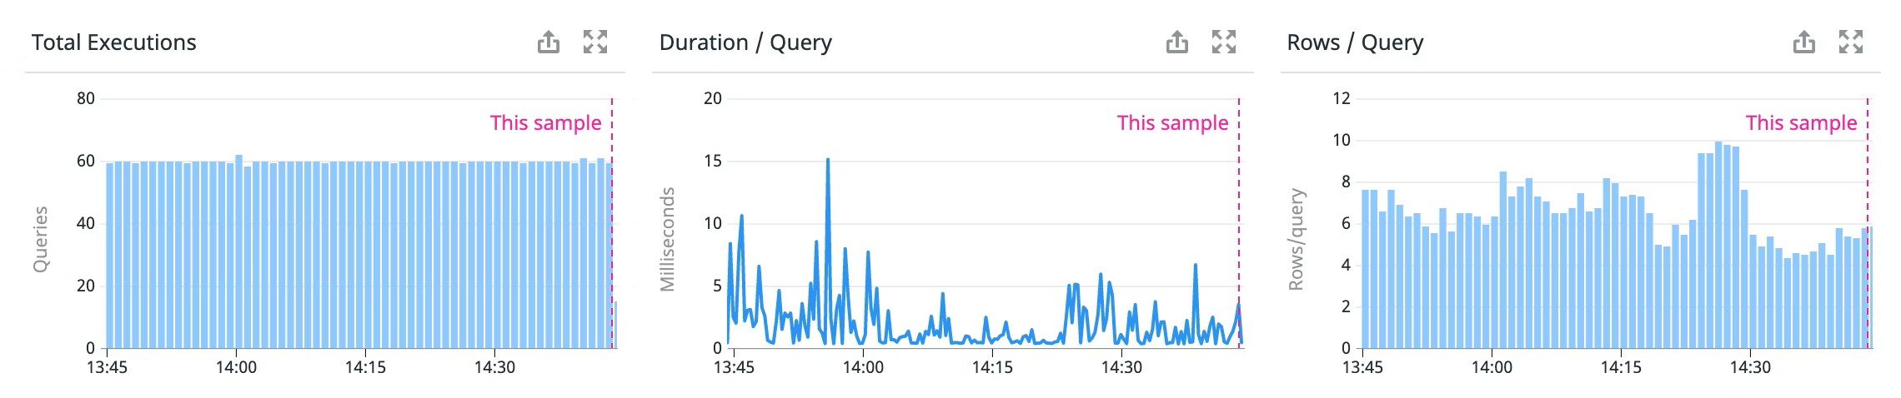

4.7 Synthetic Monitoring
Synthetic tests allow us to observe how the systems and applications are performing using requests and actions from around the globe. Datadog tracks the performance of webpages and APIs from the backend to the frontend at various network level (HTTP,SSL,DNS,websocket, TCP, UDP ,ICMP) in a controlled and stable way such as broken features, high response times and unexpected status code.
API tests
Datadog provides HTTP,SSL,DNS, WebSocket, TCP, UDP , ICMP protocols to monitor and test on it.
We have tested one API for synthetic monitoring On that, used the HTTP test of our AWS infra
HTTP test: It allow us to send the HTTP requests to our application’s API endpoints to verify the responses and defined conditions such as overall response time, expected status code, header, or body content.
HTTP tests can run from both managed and private locations depending on your preference for running the test from outside or inside your network
The following is the API tested for the test environment
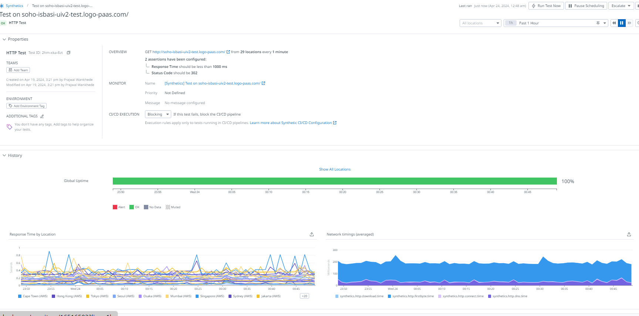

5.0 Costing plan:
Datadog has 6 pricing editions (s), from $0 to $31. Datadog’s primary pricing model is based on the number of hosts we monitor. A host can be a physical server, virtual machine, container, or cloud instance. We pay a fixed fee per host per month, depending on the plan we choose.
Pro Plan: Suitable for mid-sized environments.
Cost: Starting at $15/host/month
  - Features:
    - Centralized monitoring of systems, services, and serverless functions
    - 700+ integrations
    - Out-of-the-box dashboards
    - 15-month metric retention
Datadog’s feature plan :
APM(Application performance monitoring): It is available for 2 hosts on a trial account.
Cost: Starting at $31 /host /month
For pro plan:
Staring at $35 /host/month
Database Monitoring:
Cost: Starting at $70 /host /month
Infrastructure Monitoring :
Pro plan:
Cost: Starting At $15 /host /month
Synthetic monitoring :
Cost: Starting at $5 /host /month

